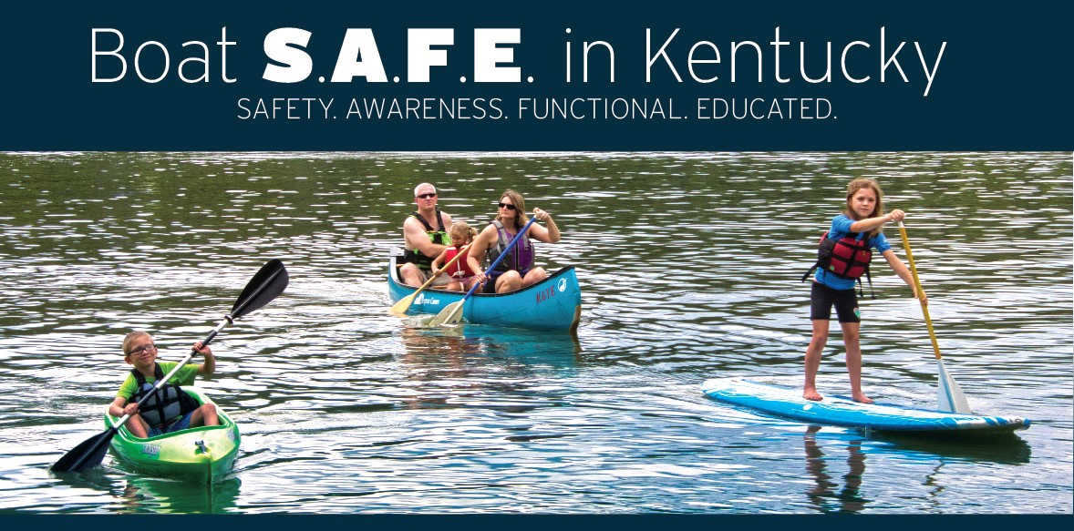

Thank you for your interest in the Life Jacket Loaner Station Program.

By providing greater access to life jackets, we can help make Kentucky’s waterways safer places for boaters and others to enjoy.

The following form helps the Kentucky Department of Fish and Wildlife Resources stay informed about needs for additional life jackets, upkeep at participating stations and interest in the program.

Donors enrolled in the program are required to submit monthly reports due at the start of each month from May-September. Outside of that timeframe, reports are due every two months.

If you are interested in partnering with Kentucky Fish and Wildlife on a new Life Jacket Loaner Station, we ask that you also complete the form so we can follow up with you.

Completed forms should be submitted by email to marcus.bowling@ky.gov. If you have any questions about the form, please feel free to contact me by email or by phone at 1-800-858-1549.

Thank you for your interest in helping boaters “Boat S.A.F.E.” in Kentucky.

Respectfully,

Marcus Bowling
Boating Education Coordinator
Law Enforcement Division
Kentucky Department of Fish and Wildlife Resources

- Are you requesting a new Life Jacket Loaner Station?

- Donor Information:
Name Address Phone
E-mail address Contact person

- Location of new or existing Life Jacket Loaner Station:

County Body of Water Location of Station

- Life jacket order for new or replacements (2 life jackets per size):
Check all that apply: Infant ☐ Child ☐ Youth ☐
Adult ☐ Oversized Adult ☐

Questions or comments (including condition and needs of Life Jacket Loaner Station):

