Offline Elk Hunting Map Instructions

- Create Free Public account on ArcGIS.com
- Download ArcGIS Field Maps from App Store and login with new ArcGIS Account.
  - 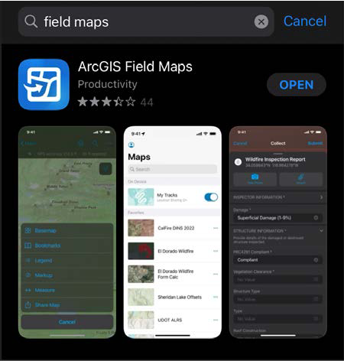
- Download Selected Elk Hunting Unit Map from KDFWR
  - Unit 2
  - Unit 3
  - Unit 4
  - Unit 5
  - Unit 6
  - Unit 7
- 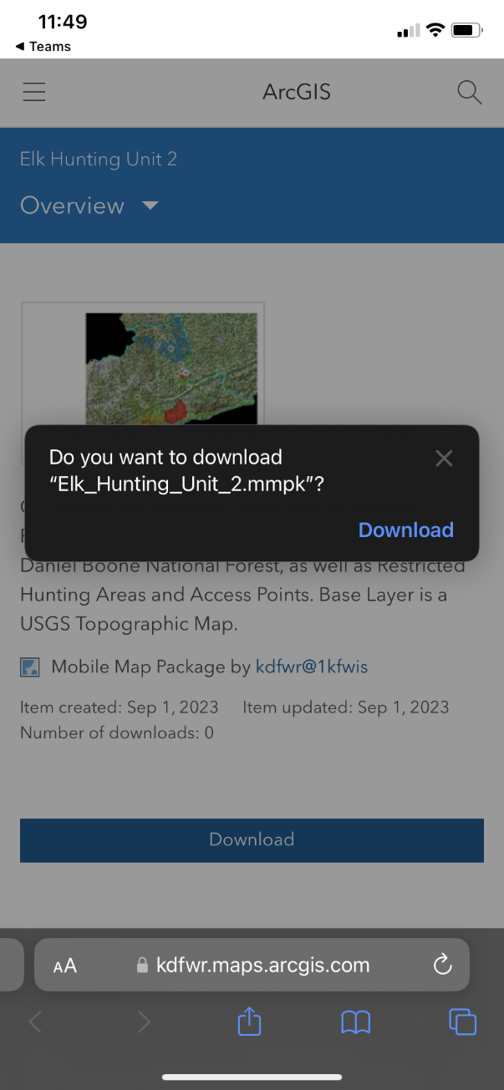

iPhone Users
- Open Files App on iPhone
  - 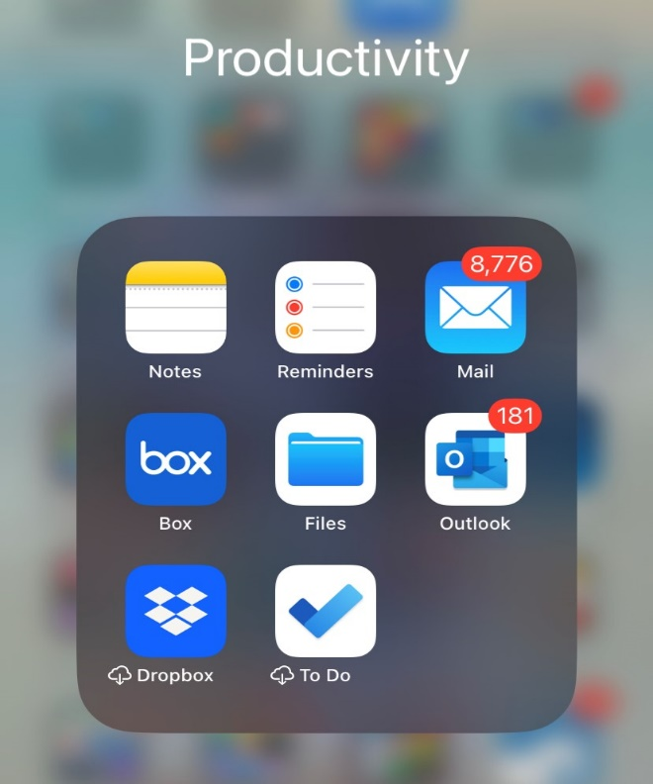
- Move .MMPK File from Downloads to Field Maps Folder
- 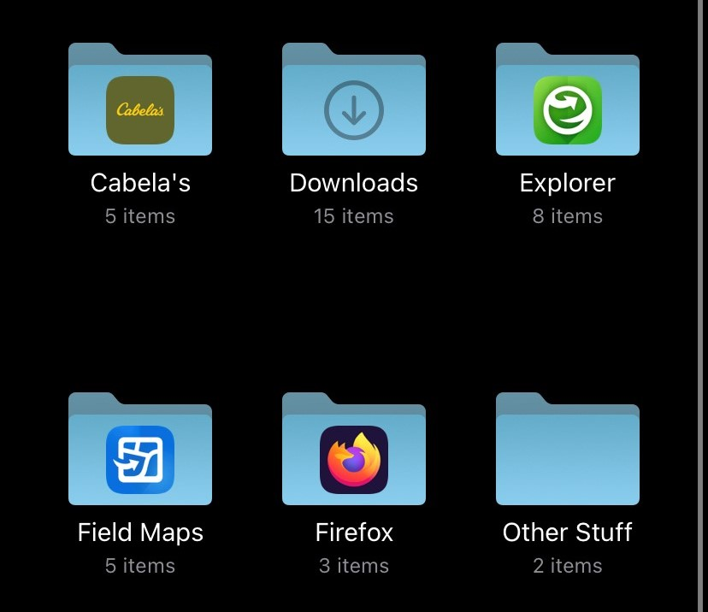
- 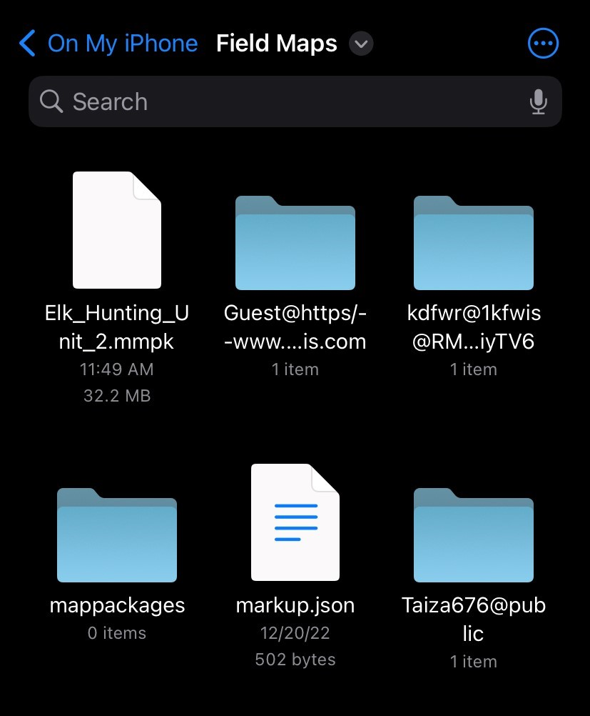
- Map Should Now be Visible in Field Maps!
- 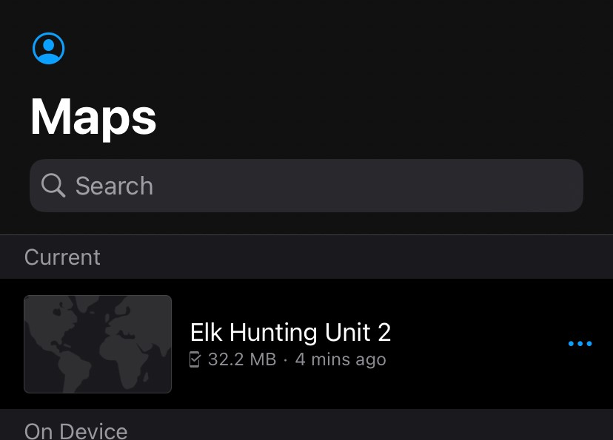

Android Users
- Same workflow as iPhone users with one exception
  - Plug your phone into your computer and place the .mmpk file in \Android\data\com.esri.fieldmaps\files\mappackages.

